**Aim:** To understand the Arduino UNO board in detail and install the Arduino IDE software.

**Components and software:**

Que 1: Give 5 name of the entry level Arduino board, enhanced features Arduino board and IoT supported Arduino board name.

1. Entry Level Arduino Board:

* Arduino Uno
* Arduino Due
* Arduino Mega
* Arduino Leonardo
* Arduino Nano

1. Enhanced Arduino Board:

* A) Arduino Ethernet
* Arduino Fio
* Arduino Nano
* Arduino LilyPad E
* Arduino Pro

1. IOT based Arduino Board:

* MKR 1000 wifi
* MKR wifi 1010
* MKR wan 1300
* MKR wan 1010
* MKR gsm 1400

Que 2: What is microcontroller? Give some application of it.

* Microcontrollers are used in automatically controlled products and devices, such as automobile engine control systems, implantable medical devices, remote controls, office machines, appliances, power tools, toys and other embedded systems.
* Microcontrollers are employed in automatically managed inventions and appliances like- power tools, implantable medical devices, automobile engine control systems, , office machines, remote controls appliances, toys and many more embedded systems.

Que 3: From which website you have downloaded the Arduino IDE software?

* <https://www.arduino.cc/en/software> .

Que 4: Write full form for

**IDE:-** Integrated Development Environment**.**

**UART**:- Universal Asynchronous Receiver-Transmitter

**I2C**: - Inter-Integrated Circuit.

**SPI**:- Serial Peripheral Interface.

**ICSP**:- In-Circuit Serial Programming.

**ISP**:- : Image Signal Processor.

**SPI**:- Serial Peripheral Interface.

**GPIO:-** General Purpose Input/Output.

Que 5: Write the below details for the Arduino UNO board.

|  |  |  |
| --- | --- | --- |
| Pins | Built-in LED Pin | 13 |
| Digital I/O Pins | 14 |
| Analog input pins | 6 |
| PWM pins | 3,5,6,9,10,11 |

|  |  |  |
| --- | --- | --- |
| Power | I/O Voltage | 5-20 V |
| Input voltage (nominal) | 7-12V |
| DC Current per I/O Pin | 20mA |
| Power Supply Connector | CABLE |

|  |  |
| --- | --- |
| Microcontroller | ATmega328P |

|  |  |  |
| --- | --- | --- |
| Memory | ATmega328P,Only 32 bytes of flash memory | 2K bytes of SRAM |

* Arduino has ___14__ digital input/output pins
* Arduino has __6___ PWM outputs pins
* Arduino has___6___ analog inputs pins
* Arduino has ___20____ MHz ceramic resonator.

**Que: Mention Connector pinouts in the diagram.**

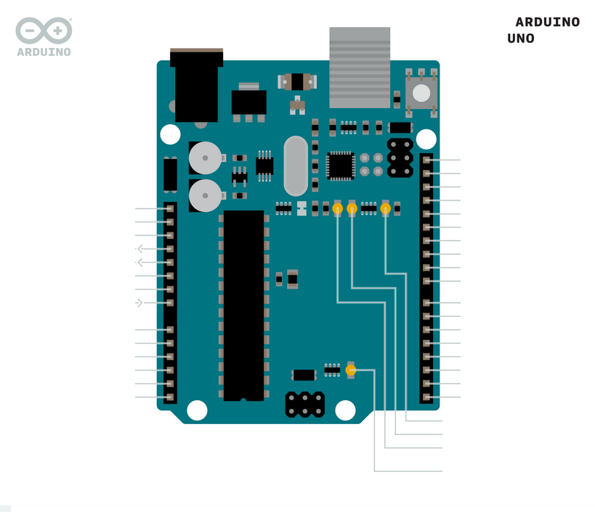

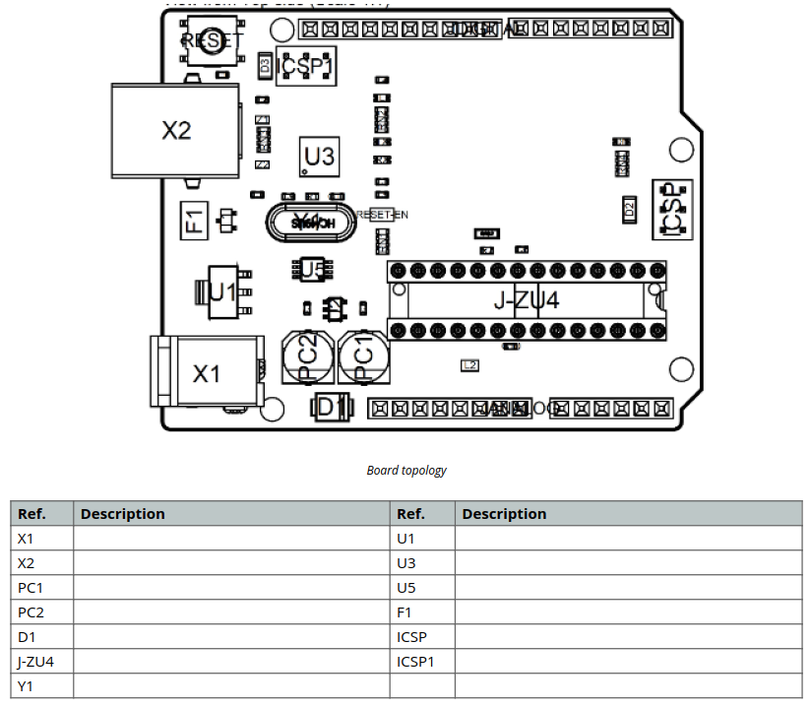 **Que: Fill the table for given ref number.**

**ICSP:**- The ability of a microcontroller to be programmed without disconnecting from circuitry.

**ICSP1:-** This is programming in which data is moved to microcontroller serially and the microcontroller then executes these instruction.

**PC1:**- Looking at the schematic that you provided, it seems likely that they serve C6.

**PC1:-** Looking at the schematic that you provided, it seems likely that they serve C7.

**X1:-** I had originally only reported the problem but this has motivated me to research what "dc" stands for. It turns out it's "data/command select". The Arduino TFT library is really just a wrapper around an outdated version of the Adafruit ST7735 library.

**X2:-** Connectors are used to join subsections of circuits together. Usually, a connector is used where it may be desirable to disconnect the subsections at some future time: power inputs, peripheral connections, or boards which may need to be replaced.

**Arduino Installation Process:**

**Step 1** − First you must have your Arduino board (you can choose your favorite board) and a USB cable. In case you use Arduino UNO, Arduino Duemilanove, Nano, Arduino Mega 2560, or Diecimila, you will need a standard USB cable (A plug to B plug), the kind you would connect to a USB printer as shown in the following image.

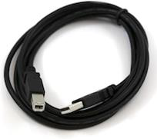

In case you use Arduino Nano, you will need an A to Mini-B cable instead as shown in the following image.

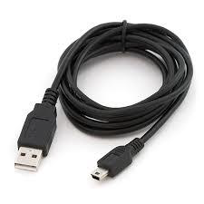

**Step 2 − Download Arduino IDE Software.**

You can get different versions of Arduino IDE from the <https://www.arduino.cc/en/software/> on the Arduino Official website. You must select your software, which is compatible with your operating system (Windows, IOS, or Linux). After your file download is complete, unzip the file.

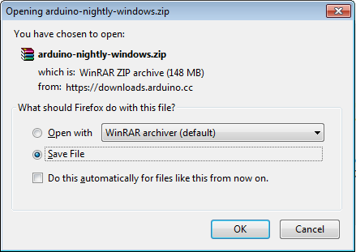

**Step 3 − Power up your board.**

The Arduino Uno, Mega, Duemilanove and Arduino Nano automatically draw power from either, the USB connection to the computer or an external power supply. If you are using an Arduino Diecimila, you have to make sure that the board is configured to draw power from the USB connection. The power source is selected with a jumper, a small piece of plastic that fits onto two of the three pins between the USB and power jacks. Check that it is on the two pins closest to the USB port.

Connect the Arduino board to your computer using the USB cable. The green power LED (labeled PWR) should glow.

**Step 4 − Launch Arduino IDE.**

After your Arduino IDE software is downloaded, you need to unzip the folder. Inside the folder, you can find the application icon with an infinity label (application.exe). Double-click the icon to start the IDE.

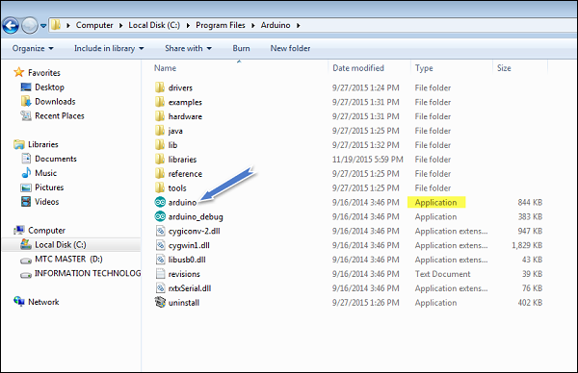

**Step 5 − Open your first project.**

Once the software starts, you have two options −

* Create a new project.
* Open an existing project example.

To create a new project, select File → **New**.

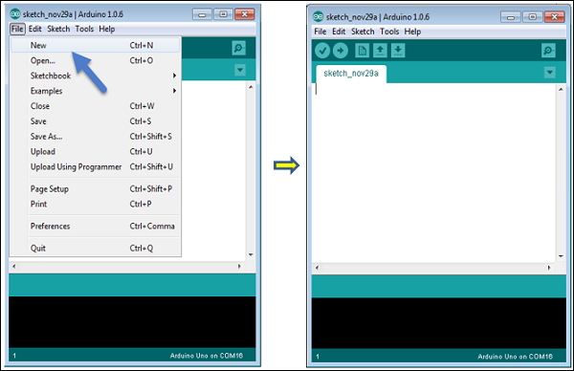

To open an existing project example, select File → Example → Basics → Blink.

Open Project

Here, we are selecting just one of the examples with the name **Blink**. It turns the LED on and off with some time delay. You can select any other example from the list.

**Step 6 − Select your Arduino board.**

To avoid any error while uploading your program to the board, you must select the correct Arduino board name, which matches with the board connected to your computer.

Go to Tools → Board and select your board.

Here, we have selected Arduino Uno board according to our tutorial, but you must select the name matching the board that you are using.

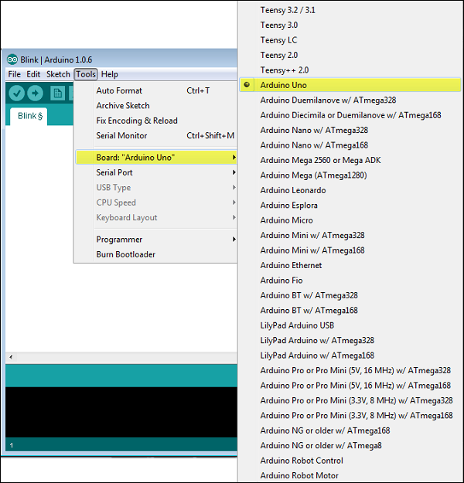

**Step 7 − Select your serial port.**

Select the serial device of the Arduino board. Go to **Tools → Serial Port** menu. This is likely to be COM3 or higher (COM1 and COM2 are usually reserved for hardware serial ports). To find out, you can disconnect your Arduino board and re-open the menu, the entry that disappears should be of the Arduino board. Reconnect the board and select that serial port.

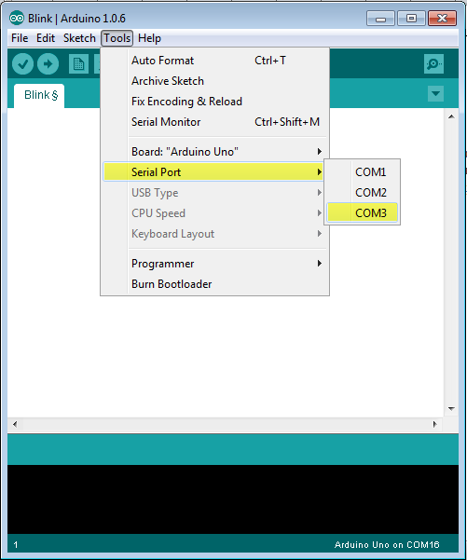

**Step 8 − Upload the program to your board.**

Before explaining how we can upload our program to the board, we must demonstrate the function of each symbol appearing in the Arduino IDE toolbar.

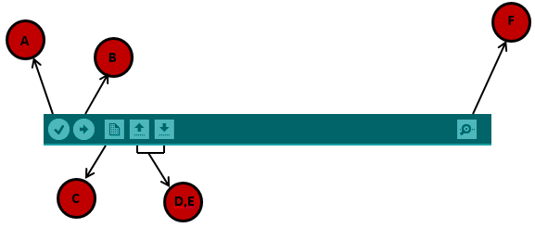

**A** − Used to check if there is any compilation error.

**B** − Used to upload a program to the Arduino board.

**C** − Shortcut used to create a new sketch.

**D** − Used to directly open one of the example sketch.

**E** − Used to save your sketch.

**F** − Serial monitor used to receive serial data from the board and send the serial data to the board.

Now, simply click the "Upload" button in the environment. Wait a few seconds; you will see the RX and TX LEDs on the board, flashing. If the upload is successful, the message "Done uploading" will appear in the status bar.

**Have you find any troubleshoot?**

**Noo.**

**Conclusion:-**